Functional Specification Document (FSD)
Travel Reimbursement App for Corporate Employees

1. Overview & Documentation Structure
1.1 Purpose
This functional specification document defines the business, functional, and non-functional requirements of a "Travel Reimbursement App for Corporate Employees". The application will be used for end-to-end business travel management by employees, managers, and finance teams, right from approval requests to submission of expenses and reimbursement.
1.2 Objectives
1) Digitize the full travel reimbursement process
2) Provide role-based dashboards and reporting
3) Ensure enforcement of corporate travel policies
4) Improve transparency and turnaround time
1.3 Stakeholders
1) Employees
2) Reporting Manager
3) HR/Admin
4) Finance Team
5) IT Support
1.4 Document Structure
1) Overview & Documentation Structure
2) Approach Note
3) Information Architecture
4) Features Documented
- Business Requirements (BRs)
- Functional Requirements (FRs)
-Non-Functional Requirements (NFRs)
-Assumptions & Constraints
-RAID Matrix
-Workflows for All Journeys
-Wireframes

2. Approach Note
The Travel Reimbursement application design will be user-centric and role-based, ensuring ease of use, automation of processes, and application of rules and policies. Agile methodology will be followed in development to enable iteration towards delivery and continuous feedback from business stakeholders.
Key approach principles:
- Role-based access control
- Automation of approval flows
- Policy-driven validations
- Mobile-first responsive design
- Secure document handling

3. Information Architecture
3.1 Core Modules
1) User Management
2) Travel Request Management
3) Receipt Upload & OCR
4) Approval Workflow Engine
5) Reimbursement Processing
6) Policy Management
7) Notifications & Alerts
8) Dashboard & Reporting
3.2 User Roles
1) Employee
2) Manager
3) Finance Officer
4) Admin
3.3 Sub-Modules
1) User Profile
2) Travel Request
3) Expense Claim
4) Receipt
5) Approval Record
6) Travel Policy

4. Features Documented
4.1 Business Requirements (BRs)
BR-01: Allow employees to raise travel requests prior to travel.
BR-02: Give managers the authority to accept or reject travel requests.
BR-03: Permit workers to file claims for post-trip expenses.
BR-04: Enforce corporate travel policies automatically.
BR-05: Give the finance team the ability to validate claims and process payouts.
BR-06: Maintain audit trail and transparency of claims.
BR-07: Generate reports for finance and management.
4.2 Functional Requirements (FRs)
Employee
FR-01: Login using corporate credentials
FR-02: Create new travel request with details
-Travel Dates
-Destination
-Purpose
-Estimated Budget
FR-03: Upload receipts with multiple image formats
FR-04: View request/claim status
FR-05: Submit reimbursement claim
FR-06: Track approval history
Manager
FR-07: Receive travel approval notifications
FR-08: Approve/Reject travel requests
FR-09: Add comments and justification
Finance
FR-10: View approved claims
FR-11: Validate receipts
FR-12: Mark claims as reimbursed
FR-13: Export claim reports
Admin
FR-14: Define travel policies
FR-15: Configure role permissions
FR-16: Manage system users
System
FR-17: Automated email & in-app notifications
FR-18: OCR extraction from uploaded receipts
FR-19: Auto policy violation warnings
FR-20: Logs & audit trail
4.3 Non-Functional Requirements (NFRs)
NFR-01: Application uptime ≥ 99.5%
NFR-02: Response time < 3 seconds
NFR-03: Secure authentication (SSO / MFA)
NFR-04: Data encryption for stored documents
NFR-05: Compatibility with major browsers and mobile devices
NFR-06: Scalable to 10,000+ users
NFR-07: Compliance with internal IT security standards
4.4 Assumptions & Constraints

Assumptions
- All users have corporate email IDs
- Travel policies are pre-defined by company
- Internet access is available

Constraints
- System must integrate with existing HRMS
- All reimbursements processed through finance ERP
- OCR accuracy depends on receipt quality
4.5 RAID Matrix
Risk – Inaccuracies in OCR impacting claim approval
Assumption - Managers will approve requests within SLA
Issue - Delay in ERP payout integration
Dependency - HRMS for user authentication

5. Workflows
5.1 Employee Journey
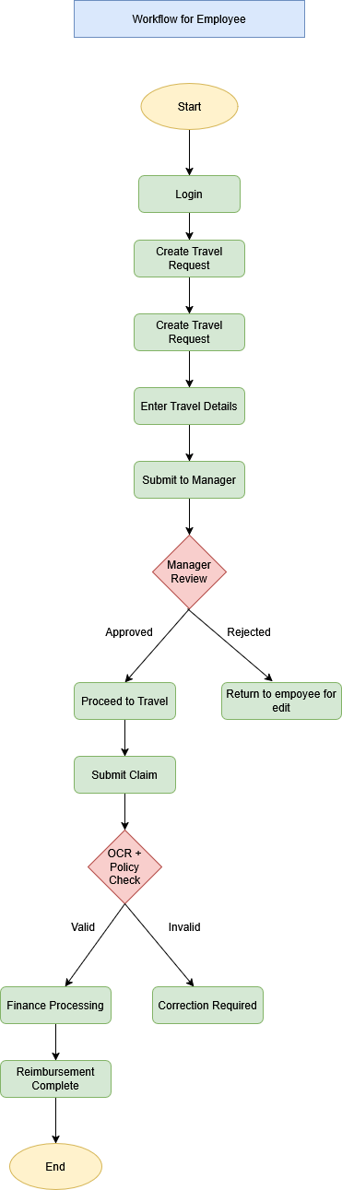
5.2 Manager Journey

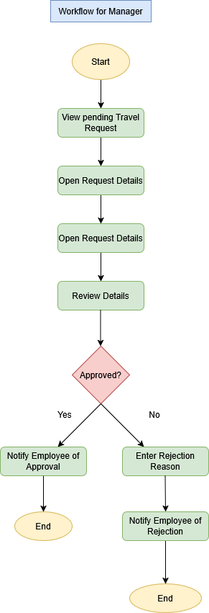
5.3 Finance Journey
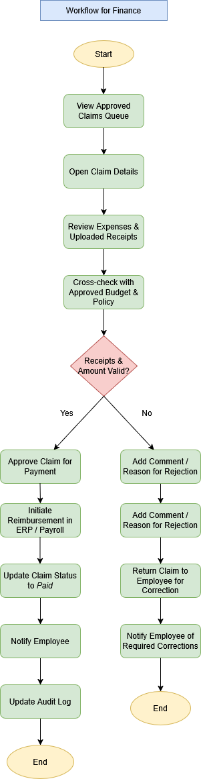
6. Wireframes
6.1 Login
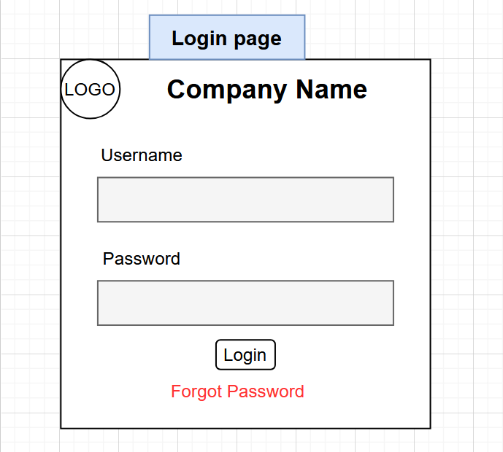
6.2 Employee Dashboard
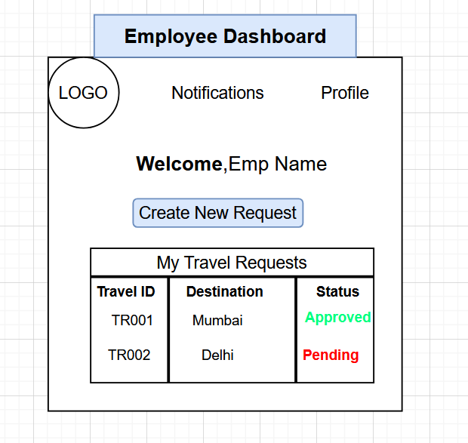

6.3 Create Travel Request Screen
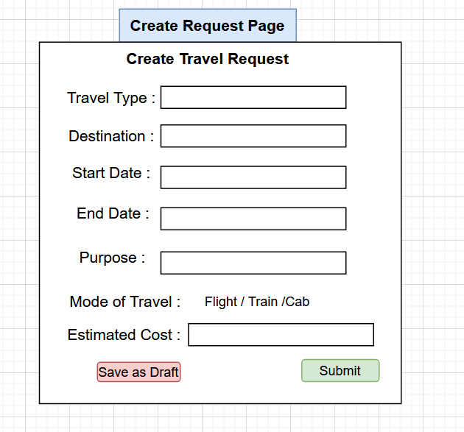
6.4 Submit Claim Screen (Post Travel)
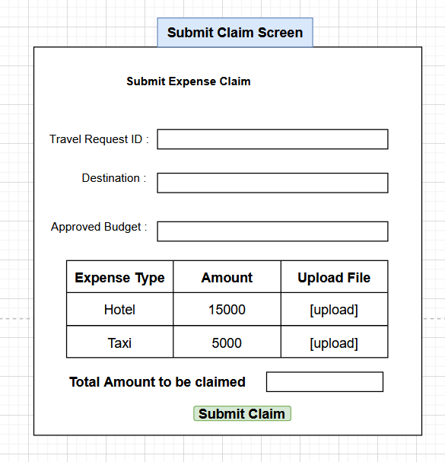

6.5 Manager Dashboard
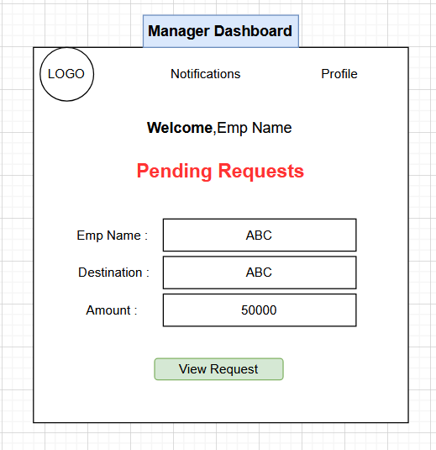

6.6 View Request Page
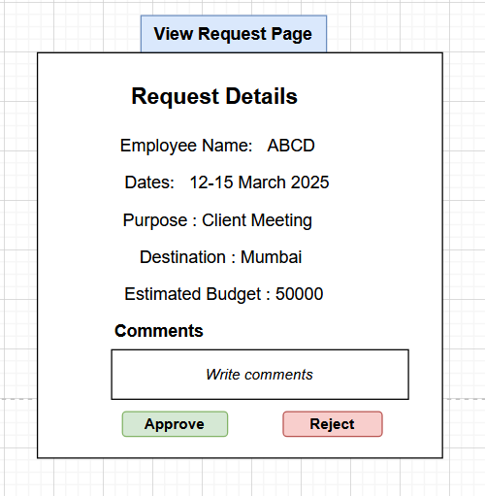

6.7 Finance Dashboard
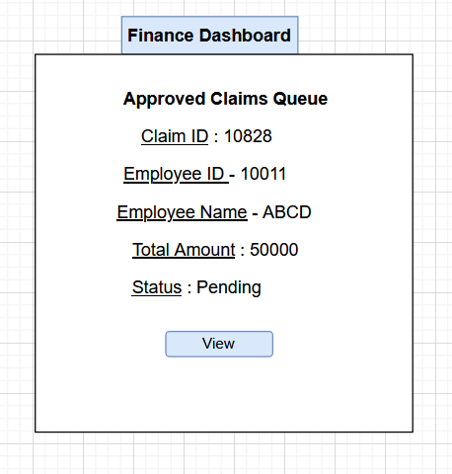
6.8 View claim details page
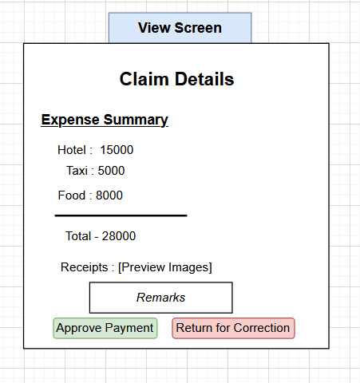

7. Overall Language Used in the Document
The language used throughout this document is professional, structured, user-friendly, and aligned with standard corporate documentation practices. It has been carefully crafted to ensure clarity, consistency, and ease of understanding for relevant stakeholders, including business users, management, and technical teams.

